STUDENT |  | GRADER
 |  |  | Total Score
  I am submitting my own work in this exercise, and I am aware of the penalties for cheating that will be assessed if I submit work for credit that is not my own.
   | Print Name |  | ID Number
   | Sign Name |  | Date
  # | Points | Score
  1 | 8
  2 | 6
  3 | 5
  4 | 14
  5 | 4
  6 | 14
  7 | 8
  8 | 15
  9 | 9
  10 | 12
 |  |  | Weeks late
Adjusted
Score
 |  |  | Adjusted  Score
  Estimated hours of work
  1 | 2 | 3 | 4 | 5 | 6 | 7 | 8 | 9 | 10
  1 | 2 | 3 | 4 | 5 | 6 | 7 | 8 | 9 | 10
  Weight
Adjusted Score:
Deduct 15% from score for each week late

Problem 1. Below are some circuit elements from a simple digital system.
Ohms Law: V = IR
Power = VI or I²R

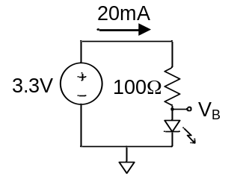
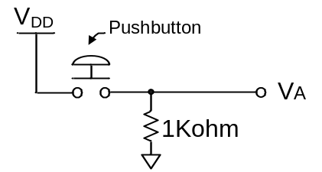
When the pushbutton is not pressed, what is the voltage at V_{A}? ________
When the pushbutton is pressed, what is the voltage at V_{A}? __________
When the pushbutton is pressed, how much current flows in the 1K resistor? ___________
What voltage V_{B} is required so that 20mA flows in the LED circuit as shown? ___________

Problem 2. An LED requires 20mA of current to show the presence of a ‘1’ output in a 3.3V system. The LED has a 1.3V threshold voltage (this voltage must be present across the LED in order for it to emit light). What size of current-limiting resistor should be used? Sketch the circuit.

Problem 3. How much power is dissipated in the resistor in the problem 2 above?

Problem 4. Complete the truth tables below.

A | B | F
AND

A | B | F
OR

A | B | F
XOR

A | F
INV

A | B | C | F
0 | 0 | 0
0 | 0 | 1
0 | 1 | 0
0 | 1 | 1
1 | 0 | 0
1 | 0 | 1
1 | 1 | 0
1 | 1 | 1
F=A’B + C

A | B | C | F
0 | 0 | 0
0 | 0 | 1
0 | 1 | 0
0 | 1 | 1
1 | 0 | 0
1 | 0 | 1
1 | 1 | 0
1 | 1 | 1
F=ABC’ + BC

A | B | C | F
0 | 0 | 0
0 | 0 | 1
0 | 1 | 0
0 | 1 | 1
1 | 0 | 0
1 | 0 | 1
1 | 1 | 0
1 | 1 | 1
F=BC’ + B’C

Problem 5. Complete the truth tables for the circuits in Figures 1 and 2 in Module 1 using 1’s and 0’s to indicate Vdd and GND.
SW1 | SW2 | F | SW1 | SW2 | F
Figure 1 Truth Table |  |  | Figure 2 Truth Table

Problem 6. Sketch a circuit similar to figure
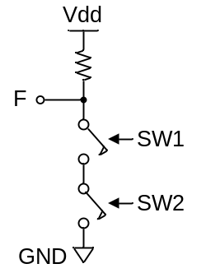
to the right that asserts logic 1
only when both switches are closed.

Describe how your sketch can be
interpreted as an AND relationship:

Describe how your sketch can be
interpreted as an OR relationship:

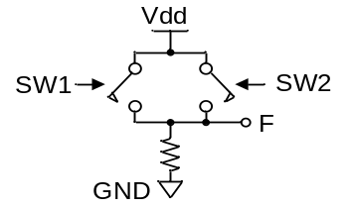

Sketch a circuit similar to the figure
to the right that asserts logic 0 only
when either switch is closed.

Describe how your sketch can be
interpreted as an AND relationship:

Describe how your sketch can be
interpreted as an OR relationship:
Problem 7. Sketch a circuit using just switches and resistors that can drive an output F to LHV if two signals A and B are at ‘0’, or if a third signal C is at ‘1’ regardless of the state of A and B (assume a ‘1’ closes a switch, and ‘0’ opens a switch).

Problem 8. Complete the truth tables below (enter “on” or “off” under each transistor entry), and enter the gate name and schematic shapes in the tables.

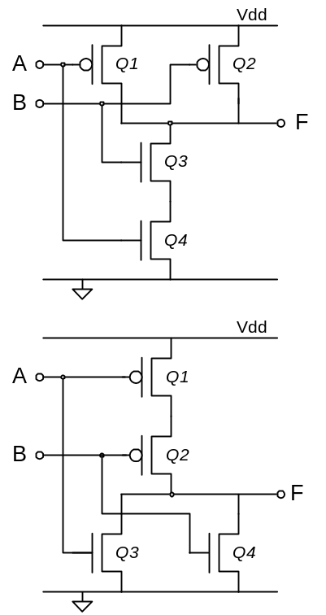

A | B | Q1 | Q2 | Q3 | Q4 | F
0 | 0
0 | 1
1 | 0
1 | 1

Gate
Name
AND shape |  | OR shape

A | B | Q1 | Q2 | Q3 | Q4 | F
0 | 0
0 | 1
1 | 0
1 | 1

Gate
Name
AND shape |  | OR shape

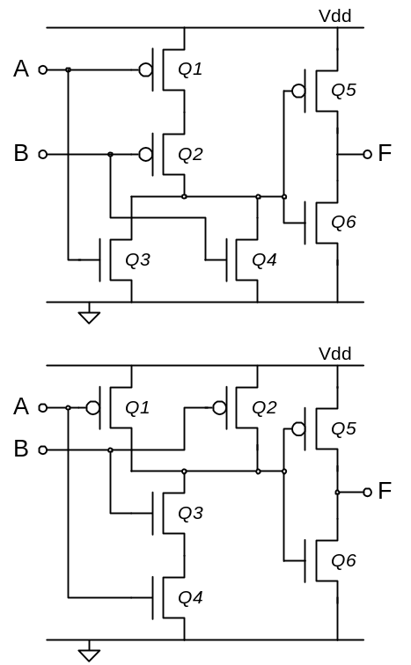

A | B | Q1 | Q2 | Q3 | Q4 | F
L | L
L | H
H | L
H | H

Gate
Name
AND shape |  | OR shape

A | B | Q1 | Q2 | Q3 | Q4 | F
L | L
L | H
H | L
H | H

Gate
Name
AND shape |  | OR shape

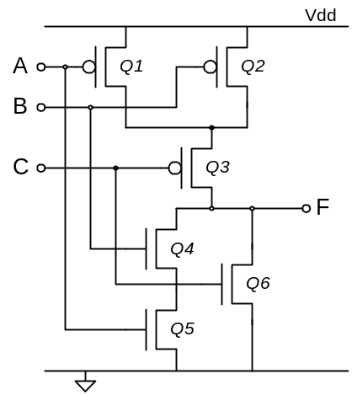
A | B | C | Q1 | Q2 | Q3 | Q4 | Q5 | Q6 | F
L | L | L
L | L | H
L | H | L
L | H | H
H | L | L
H | L | H
H | H | L
H | H | H

F =
Enter the logic equation for the 3-input circuit above:

Problem 9: Complete the following.

A. A pFET turns [ ON / OFF ] with LLV and conducts [ LHV / LLV ] well (circle one in each bracket).
B. An nFET turns [ ON / OFF ] with LLV and conducts [ LHV / LLV ] well (circle one in each bracket).

C. Write the number of transistors used in each gate:

NAND: _____ OR: _____ INV: _____ AND: _____ NOR: ______

Problem 10. In a logic function with n inputs, there are 2^{n} unique combinations of inputs and 2^{2n} possible logic functions. The table below has four rows that show the four possible combinations of two inputs (2² = 4), and 16 output columns that show all possible two-input logic functions (2²² = 16). Six of these output columns are associated with common logic functions of two variables. Circle the six columns, and label them with the appropriate logic gate name. Draw the circuit symbols for the functions represented

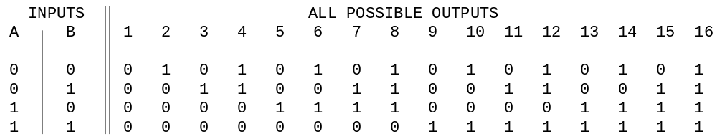

A table like the one above for 3 inputs would need _________ rows and _________ columns.
A table like the one above for 4 inputs would need _________ rows and _________ columns.
A table like the one above for 5 inputs would need _________ rows and _________ columns.

Problem 11. Sketch circuits for the following logic equations (a ‘ following a variable means the variable should be inverted).

F = A’.B.C + A.B’.C’ + A’.C

F = (A’.B.C’)’ + (A + B)’

F = (A + B’) . ((B + C)’ . A’)’

Problem12. Write logic equations for the following circuits.
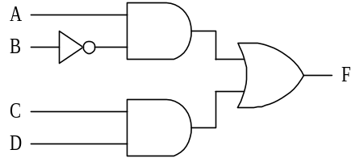

F =
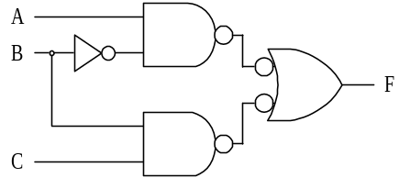
F =

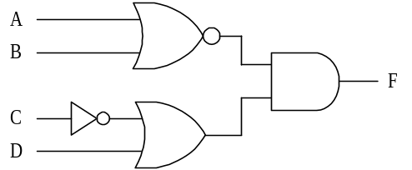
F =
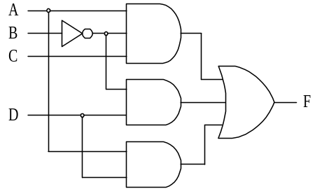

F =

